THIS BUILDING HAS BEEN REDESIGNATED A
MEDICAL & HEALTH SERVICE FACILITY
EFFECTIVE FROM 5TH NOVEMBER 2020

Under the 2020 No. 1200 PUBLIC HEALTH, ENGLAND The Health Protection (Coronavirus, Restrictions) (England) (No. 4) Regulations 2020 section 17: this building when redesignated for the purpose of providing medical services may remain OPEN.
Specifically, SCHEDULE Regulations 15(7), 16(4) and 18(1) Businesses permitted to remain open, Part 3 section 47
“47. Dental services, opticians, audiology services, chiropody, chiropractors, osteopaths and other medical or health services, including services relating to mental health.”

IF YOU NEED TO USE OUR SERVICES PLEASE CONTACT US FIRST AS WE CANNOT ACCEPT WALK-IN CLIENTS WITHOUT INITIAL SCREENING. WE WILL THEN SCHEDULE AN APPOINTMENT

WE ARE A BUSINESS SUPPORTING THE NHS
BY ALLEVIATING PRESSURE ON THEIR SERVICES

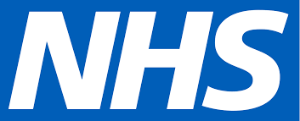

STAY SAFE: WEAR MASK – WASH HANDS – KEEP DISTANCE

